1. To communicate with Messaging Server, a Developer needs APIs.
2. These Messaging Server could be **ActiveMQ, WebSphere MQ, Sonic MQ, Tibco MQ** (They are servers as they run on its own URL).
   1. Like ActiveMQ Server has its own IP and PORT and it provides proprietary **APIs.  
      Through this APIs we communicate with ActiveMQ Server.**Similar is the case with other Messaging Server such as WebSphere MQ, Sonic MQ, Tibco MQ.
3. If currently system is communicating through ActiveMQ server and it is replaced with WebSphere MQ, then in code base we need to change the APIs as per WebSphere MQ which is overhead.   
   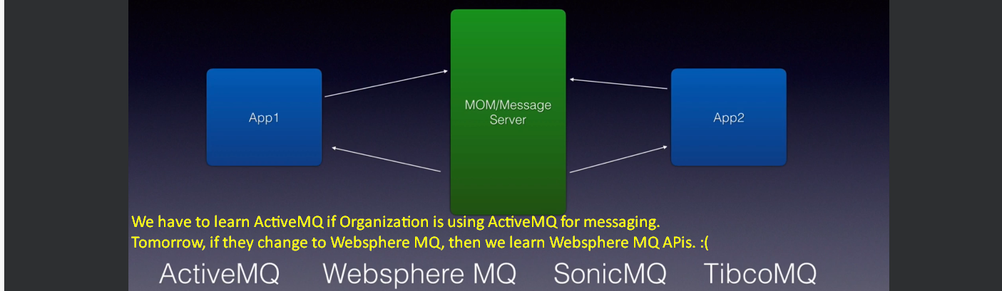
4. That is where JMS Standard came in introduced by Sun Microsystem now maintained by Oracle.  
   Like any other Java EE Standard, it has 🡺 Specification and API.
5. **Specification**: A set of rules in plain English **for messaging servers** like ActiveMQ, WebSphere MQ etc.  
   They follow the specification and implement the JMS Standard.  
   **API**: **For Developers**.
6. Now as a developer, we do not need to learn all the APIs from different Messaging Vendor like ActiveMQ, WebSphere MQ etc.   
   We will learn just JMS API to communicate with any Messaging Server (ActiveMQ, WebSphere MQ etc). 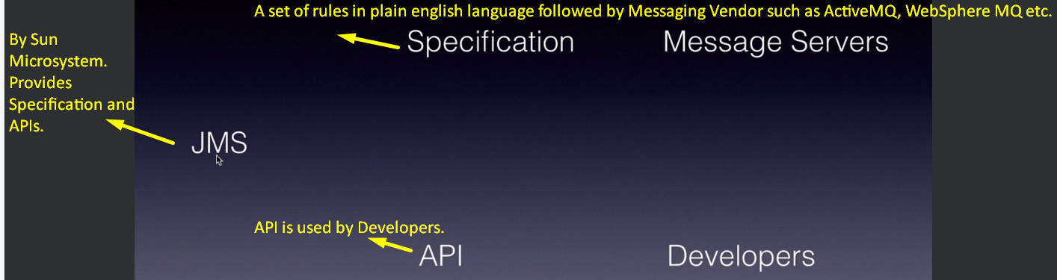
7. 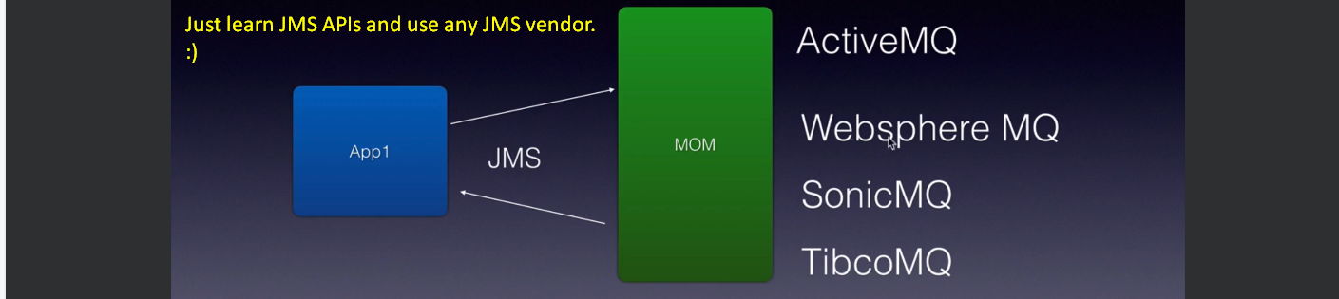
8. 